FIREWORKS TENT SITE APPROVAL APPLICATION

Submit Application and Fee to: State Building Approvals
1415 Shakerag Rd.,
Hanson, KY 42413

Name of Person of Company Submitting Plans: _______________________________________________________________________________________________
Mailing Address: __________________________________________________________________________________________________________________________
NUMBER / STREET, HWY, ROAD or P. O. BOX CITY STATE ZIP
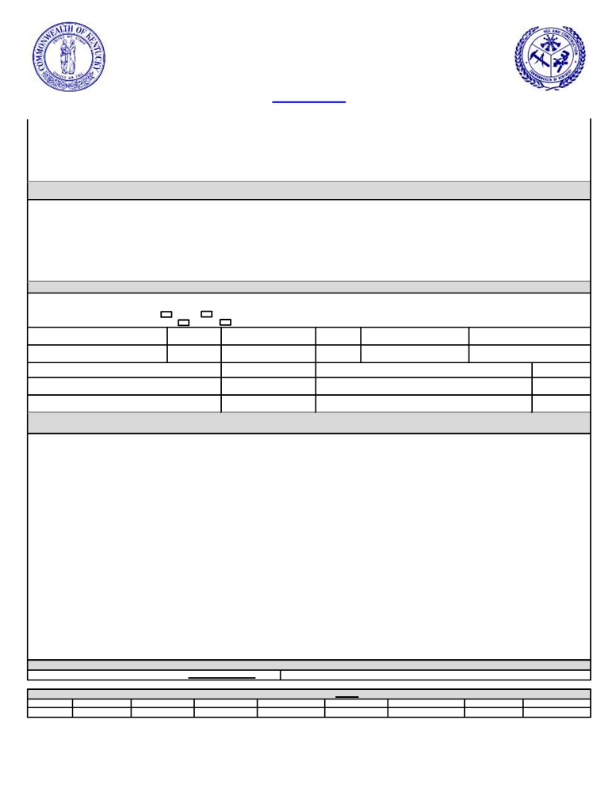
Name of Contact Person ___________________________________ Phone # (_____) _____ - _____ EXT _____ Cell Phone # (_____ ) _____ - _____
Fax No: (_______) _______ - _______ E-Mail Address __________________________________________________________________
TENT INSTALLER INFORMATION
Name of Tent Installer: ____________________________________________________________________________________________________________________

Mailing Address: __________________________________________________________________________________________________________________________
NUMBER / STREET, HWY, ROAD or P. O. BOX CITY STATE ZIP
Name of Contact Person
Phone # (_______) _______ - _______ EXT _______ Cell Phone # (_______ ) _______ -
Fax No: (_______) _______ - _______ E-Mail Address __________________________________________________________________
TENT INFORMATION
Address of Tent Location ______________________________________________________City _____________________ County ____________________________

Tent located within the city limits? Yes
Is the tent in the parking lot of a business? Yes
NO
NO If yes, what is the name of the business: _____________________________________________
TOTAL SQUARE FEET IN

NUMBER OF TENTS TO BE ERECTED
TENT MODEL APPROVAL NUMBER FOR
EACH TENT OVER 400 SQUARE FEET
DISTANCE TO PROPERTY LINE

DISTANCE TO ANY ABOVEGROUND STORAGE TANKS

DISTANCE TO THE NEAREST MOTOR FUELING DISPENSERS
TENT(S)

DATE OF TENT ERECTION
SQUARE FOOT OF EACH TENT

PROPOSED DATE OF REMOVAL

DISTANCE TO NEAREST BUILDING

DISTANCE TO ANY PROPANE DISPENSING STATION

DISTANCE TO THE NEAREST MOTOR FUELING DISPENSERS

SITE DRAWING

Provide a site plan showing dimensions of the area provided to be used for tent, the location and construction of any buildings.

Make all checks/money orders payable to Kentucky State Treasurer
Single Tent - 399 Square Foot Tent of Less - NO Charge for review Single Tent - 400 Sq. Ft. or More - $150.00

Fees for Aggregate Square Footage of Multiple Tents Area
400 - 2,000 2,001- 5,000 5,001 - 10,000 10,001 - 15,000 15,000 - 20,000 20,001 - 30,000 30,001 - 50,000 50,001 - 70,000 70,001 - 100,000
$250.00 $350.00 $500.00 $750.00 $950.00 $2,000.00 $2,850.00 $3,250.00 $4,000.00

All information provided herein is accurate and true to the best of my knowledge. Signature of Applicant: ____________________________ Date: ________

